**Nháy 1 led,8 led.**

1. Các linh kiện cần dùng

* AT89C52

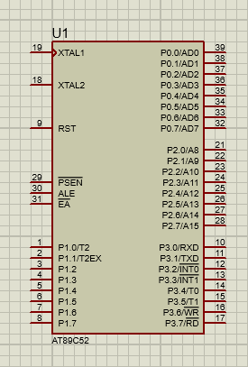

* LED-Green

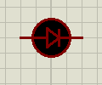

* RES (270Ω)

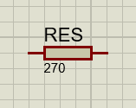

* Điện trở thanh ( RESPACK-8)

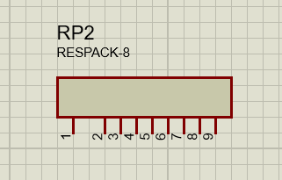

* POWER,GROUND.

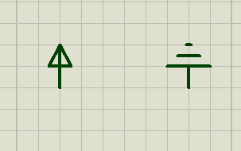

1. Nháy 1 LED
   1. Sơ đồ nguyên lý

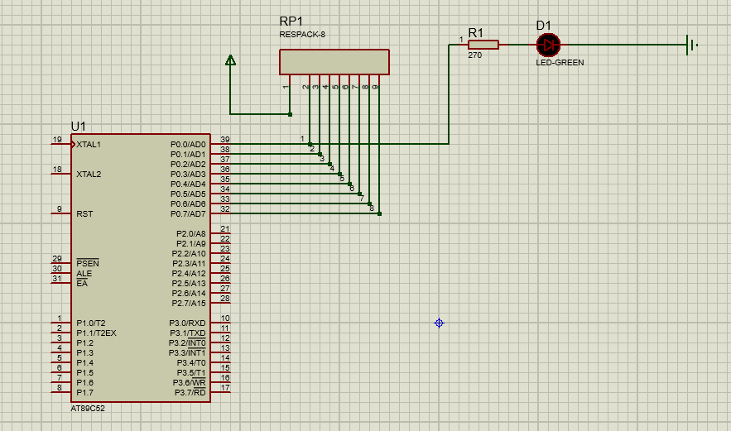

* 1. Code

#include<regx52.h>

void Delay_ms**(**unsigned int t**)//define function delay**

**{**

unsigned int x**,**y**;**

**for(**x**=**0**;**x**<**t**;**x**++)**

**{**

**for(**y**=**0**;**y**<**123**;**y**++);//lost 1ms for quartz 12Mhz**

**}**

**}**

void main**()**

**{**

**while(**1**)**

**{**

P0_0**=**0**;** // give power 0 to port P0.0 => LED off

Delay_ms**(**100**);**

P0_0**=** 1**;** // give power 1 to port P0.0=> LED on

Delay_ms**(**100**);**

**}**

**}**

1. Nháy 8 LED
   1. Sơ đồ nguyên lý

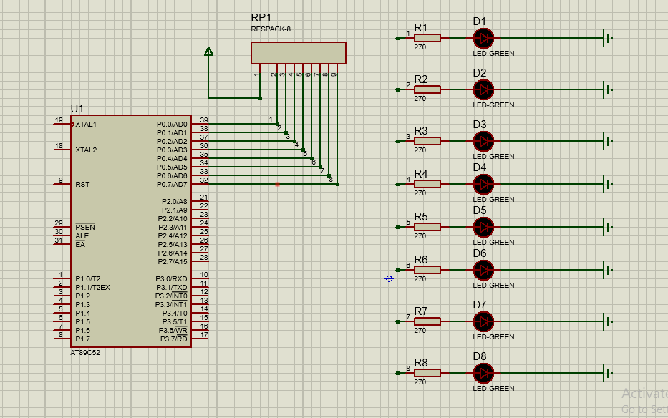

* 1. Code

#include<regx52.h>

void Delay_ms**(**unsigned int t**)**

**{**

unsigned int x**,**y**;**

**for(**x**=**0**;**x**<**t**;**x**++)**

**{**

**for(**y**=**0**;**y**<**123**;**y**++);**

**}**

**}**

void main**()**

**{**

**while(**1**)**

**{**

Delay_ms**(**1000**);**

P0**=** **~** P0**;** // P0 = 1111 1111 => All at P0 turn on

Delay_ms**(**1000**);**

P0**=** 0x55**;** // P0 = 0101 0101 => Turn on led : 1,3,5,7

Delay_ms**(**1000**);**

P0**=** 0xAA**;** // P0 = 1010 1010 => Turn on led : 2,4,6,8

Delay_ms**(**1000**);**

P0**=** 0xFF**;** // P0 = 1111 1111 => All led at P0 turn on

**}**

**}**

Lưu ý:Mức 0 đèn sẽ tắt,mức 1 đèn bật.`~` là đảo byte